

COSHH ASSESSMENT SHEET

Date of Assessment: 04.02.2025 Assessment No: CA 08 Assessor: Daniel Looney

Overall Assessment Rating of Risk [ √ ] Low [[ √ ] Medium [ ] High [ ]

|  |  |  |  |  |  |  |  |  |  |  |  |  |  |  |  |  |  |  |  |  |
| --- | --- | --- | --- | --- | --- | --- | --- | --- | --- | --- | --- | --- | --- | --- | --- | --- | --- | --- | --- | --- |
| **Work Activity:** Hard Surface cleaner for kitchen and catering areas | | | | | | | | | | |  | | | | | | | | | |
| **Persons at Risk:** | | | | User [√] Colleagues [√] Contractors [ ] Public [ ] Others **[** ] | | | | | | | | | | | | | | | | |
|  | | | | | | | | | | | | | | | | | | | | |
| **Name of Hazardous Substance:** | | | | | **E5 Eco- Dose Bactericidal H/S** | | | | | | | | | | | | | | | |
| **Manufacturer (address/tele no):** | | | | | Foremost Pro Ltd T/A Foremost. Unit 3 Dickinson Place, South Bersted Business Park, Bognor Regis, West Sussex,PO22 9QU. | | | | | | | | | | | | | | | |
| **SDS Version:** | | | | | 10.61 | | | | | | | | | | | | | | | |
| **Supplier (address/tele no):** | | | | | **01243771340** | | | | | | | | | | | | | | | |
| **Hazard data sheet attached:** | | | | | Yes [ √ ] No [ ] | | | | | | | | | | | | | | | |
| **Description/colour:** | | | | | Red | | | | | | | | | | | | | | | |
|  | **Container size in litres/kg** | | |  | **20**  **litre/kg** | | | **10**  **litre/kg** | | | | **5 litre/kg** | | | **>litre/kg** | | **< litre/kg** | | **Other** | |
|  | (tick as appropriate) | |  |  |  | | |  | | | |  | | | √ | |  | |  | |
| **HAZARD** (tick all that apply) | | | | | | | | | | | | | | | | | | | | |
|  | Corrosive | Flammable | Oxidising | | | | Corrosive | | Toxic | | | | Environmentally damaging | |  | | Health hazard | | Compressed gas |  |
|  | Explosive (Symbol: exploding bomb) | Flammable (Symbol: flame) | Oxidising (Symbol: flame over circle) | | | | Corrosive (Symbol: Corrosion) | | Acute toxicity (Symbol: Skull and crossbones) | | | | Hazardous to the environment (Symbol: Dead tree and fish) | | Health hazard/Hazard ous to the ozone layer (Symbol: Exclamation mark) | | Serious health hazard (Symbol: health hazard) | | Gas under pressure (Symbol: Gas cylinder) |  |
|  |  |  |  | | | | √ | |  | | | | √ | |  | |  | |  |  |
| **Known exposure levels:**  **W.E.L.** (where applicable) | | | | | |  | | | | | | | | | | | | | | |
| **Likely route of entry to body:**  (tick all that apply) | | | | | | **Inhaled** | | | | **Ingested** | | | | **Absorbed by skin** | | **Eyes** | | **Other** | | |
|  | | | | | | √ | | | |  | | | | √ | | √ | |  | | |
| **Areas of use/exposure:** | | | | | | **Detergent for Kitchen and catering** | | | | | | | | | | | | | | |

|  |  |  |  |
| --- | --- | --- | --- |
| **CONTROL MEASURES** | | | |
| **Can the exposure/use be eliminated or substituted?** | (tick as appropriate) | **Yes** | **No** √ |

|  |  |  |  |  |  |  |  |
| --- | --- | --- | --- | --- | --- | --- | --- |
| **Is monitoring required?** | (tick as appropriate) | | | **Yes** | | **No** √ | |
| **Local exhaust ventilation required?** | (tick as appropriate) | | | **Yes** | | **No** √ | |
| **Documented working method available on safe use and**  **handling?** | (tick as appropriate) | | | **Yes** √ | | **No** | |
| **Storage:** | **Maximum amount to be stored on site** | **Secure store out of reach of service**  **users and children** | **Store to be well ventilated** | | **Separate storage facility available or required** | | **Other** |
| (tick all that apply) |  | √ | √ | |  | |  |
| **Method of use.** | **Use undiluted** | **Use diluted** | **Wash hands after use** | | **Do not mix with other products** | | **Special precaution s** |
| (tick all that apply) |  | √ |  | |  | |  |
| **State any special/storage requirements or other precautions not listed above:**  Suitable extinguishing media: Carbon dioxide, dry powder, foam | | | | | | | |

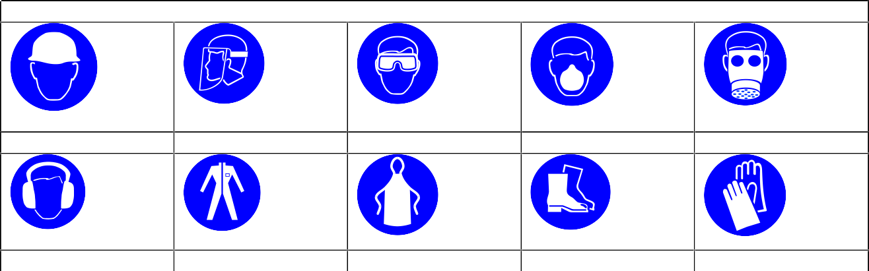

**PERSONAL PROTECTIVE EQUIPMENT REQUIREMENT.** (tick as appropriate)

**Hard Hats**

**Face Protection**

**Eye Protection:** √

**Dust Mask**

**Respirator**

**Ear Protection**

**Overalls**

**Apron**

**Foot Protection**

**Gloves:** √

|  |  |  |  |
| --- | --- | --- | --- |
| **Type of PPE & Model Nos** | | | **Type of PPE & Model Nos** |
| Safety Glasses EN166 | | | Chemical resistant gloves EN374 |
| **Who orders PPE?** | **Area Manager** | | |
| **EMERGENCY CONTROLS** | | | |
| **First Aid: Eyes** | | Promptly wash eyes with plenty of water while lifting the eyelids. Continue to rinse for several minutes. Get medical attention if any  discomfort continues. | |
| **Skin** | | Rinse skin immediately with lots of soap and water. Get medical attention if irritation persists. | |
| **Inhalation** | | Move exposed person to fresh air at once. Rinse mouth and nose with water. Get medical attention if any discomfort continues. | |
| **Ingestion** | | Do not induce vomiting. Remove victim immediately from source of exposure. , drink nothing or little water. Get medical attention. | |
| **Dealing with spillage:** | | Soak up spillage with inert solids such as clay | |
| **Disposal:** | | Empty containers to be disposed of in waste containers on site. | |
| **Precautions already in place:** | | PPE, method statements, induction & on-going training | |
| **Advice available from?** | | Foremost | |

2