

COSHH ASSESSMENT SHEET

Date of Assessment: 04.02.2025 Assessment No: CA 13 Assessor: Daniel Looney

Overall Assessment Rating of Risk [ √ ] Low [√ ] Medium [ ] High [ ]

|  |  |  |  |  |  |  |  |  |  |  |  |  |  |  |  |  |  |  |  |  |
| --- | --- | --- | --- | --- | --- | --- | --- | --- | --- | --- | --- | --- | --- | --- | --- | --- | --- | --- | --- | --- |
| **Work Activity:** | | | | | | | | | | | Gum, graffiti and mark removal. | | | | | | | | | |
| **Persons at Risk:** | | | | User [√] Colleagues [√] Contractors [ ] Public [ ] Others **[** ] | | | | | | | | | | | | | | | | |
|  | | | | | | | | | | | | | | | | | | | | |
| **Name of Hazardous Substance:** | | | | | **Biological gum, mark and graffiti remover** | | | | | | | | | | | | | | | |
| **Manufacturer (address/tele no):** | | | | | Foremost Pro Ltd T/A Foremost  Unit 3 Dickinson Place, South Bersted Business Park  Bognor Regis, West Sussex  Po22 9qu | | | | | | | | | | | | | | | |
| **SDS Version:** | | | | | 2 | | | | | | | | | | | | | | | |
| **Supplier (address/tele no):** | | | | | 01243 771 340 | | | | | | | | | | | | | | | |
| **Hazard data sheet attached:** | | | | | Yes [ √ ] No [ ] | | | | | | | | | | | | | | | |
| **Description/colour:** | | | | | Clear | | | | | | | | | | | | | | | |
|  | **Container size in litres/kg** | | |  | **20**  **litre/kg** | | | **10**  **litre/kg** | | | | **5 litre/kg** | | | **>litre/kg** | | **< litre/kg** | | **Other** | |
|  | (tick as appropriate) | |  |  |  | | |  | | | |  | | |  | | √ | |  | |
| **HAZARD** (tick all that apply) | | | | | | | | | | | | | | | | | | | | |
|  | Corrosive | Flammable | Oxidising | | | | Corrosive | | Toxic | | | | Environmentally damaging | |  | | Health hazard | | Compressed gas |  |
|  | Explosive (Symbol: exploding bomb) | Flammable (Symbol: flame) | Oxidising (Symbol: flame over circle) | | | | Corrosive (Symbol: Corrosion) | | Acute toxicity (Symbol: Skull and crossbones) | | | | Hazardous to the environment (Symbol: Dead tree and fish) | | Health hazard/Hazard ous to the ozone layer (Symbol: Exclamation mark) | | Serious health hazard (Symbol: health hazard) | | Gas under pressure (Symbol: Gas cylinder) |  |
|  |  |  |  | | | |  | |  | | | |  | | √ | |  | |  |  |
| **Known exposure levels:**  **W.E.L.** (where applicable) | | | | | | 8 hour TWA  5 PPM 33 mg/m3 | | | | | | | | | | | | | | |
| **Likely route of entry to body:**  (tick all that apply) | | | | | | **Inhaled** | | | | **Ingested** | | | | **Absorbed by skin** | | **Eyes** | | **Other** | | |
|  | | | | | | √ | | | |  | | | | √ | | √ | |  | | |
| **Areas of use/exposure:** | | | | | | **Hard surfaces / fabric containing marks, gum or graffitti** | | | | | | | | | | | | | | |

|  |  |  |  |
| --- | --- | --- | --- |
| **CONTROL MEASURES** | | | |
| **Can the exposure/use be eliminated or substituted?** | (tick as appropriate) | **Yes** | **No** √ |

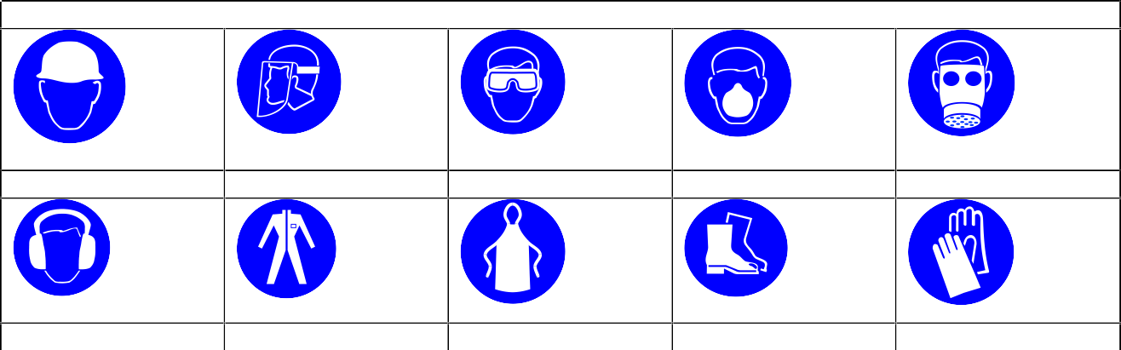

**PERSONAL PROTECTIVE EQUIPMENT REQUIREMENT.** (tick as appropriate)

**Hard Hats**

**Face Protection**

**Eye Protection:** √

**Dust Mask**

**Respirator**

**Ear Protection**

**Overalls**

**Apron**

**Foot Protection**

**Gloves:** √

|  |  |  |  |  |  |  |  |
| --- | --- | --- | --- | --- | --- | --- | --- |
| **Is monitoring required?** | (tick as appropriate) | | | **Yes** | | **No** √ | |
| **Local exhaust ventilation required?** | (tick as appropriate) | | | **Yes** | | **No** √ | |
| **Documented working method available on safe use and**  **handling?** | (tick as appropriate) | | | **Yes** √ | | **No** | |
| **Storage:** | **Maximum amount to be stored on site** | **Secure store out of reach of service**  **users and children** | **Store to be well ventilated** | | **Separate storage facility available or required** | | **Other** |
| (tick all that apply) |  | √ | √ | |  | |  |
| **Method of use.** | **Use undiluted** | **Use diluted** | **Wash hands after use** | | **Do not mix with other products** | | **Special precaution s** |
| (tick all that apply) |  | √ | √ | | √ | |  |
| **State any special/storage requirements or other precautions not listed above:**  Suitable extinguishing media: Carbon dioxide, dry powder, foam | | | | | | | |

|  |  |  |  |
| --- | --- | --- | --- |
| **Type of PPE & Model Nos** | | | **Type of PPE & Model Nos** |
| Safety Glasses EN166 | | | Gloves – EN374 Chemical resistant |
| **Who orders PPE?** | **Area Manager** | | |
| **EMERGENCY CONTROLS** | | | |
| **First Aid: Eyes** | | Immediately flush eyes with water for at least 15 minutes and seek medical attention if irritation develops. | |
| **Skin** | | Wash skin with plenty of water. Take off immediately all contaminated clothing and wash it before reuse. Get medical advice/attention. | |
| **Inhalation** | | NA | |
| **Ingestion** | | Do NOT induce vomiting. Rinse mouth with water | |
| **Dealing with spillage:** | | Take up liquid spill into absorbent material. | |
| **Disposal:** | | Empty containers to be disposed of as hazardous waste | |
| **Precautions already in place:** | | PPE, method statements, induction & on-going training | |
| **Advice available from?** | | Foremost | |

2