
Health & Safety Policy
- Introduction
The commitment to Health and Safety is of prime importance to Nationwide Cleaning & Support Services Ltd. The company will carry out its activities in such a way that prevents harm being caused to its own employees, our customer’s employees, or members of the public.
The policy sets out in detail how we will manage Health & Safety and sets out the responsibilities of all our employees within the system.
The performance of the system will be measured by audit on a quarterly basis. Where weaknesses are identified, corrective actions will be implemented immediately.
- Aims
The main aims of the policy are to provide a safe and healthy working environment and to ensure the systems provides continuous improvement of the systems and procedures.
- Objectives
- Establish and maintain an effective Health and Safety system that manages all aspects of health, safety and environmental issues that may arise from our work activities.
- Identify the hazards and assess the risks arising as a result of our work activities. Ensure hazards are eliminated where possible or implement all reasonably practicable actions required to control the risks. Review these risks on a regular basis or immediately if the work activity changes significantly.
- Provide suitable training so as to ensure our employees are competent to carry out their work activities.
- Investigate accidents in the workplace and implement corrective actions where necessary.
- Consult and co-operate with our customers.
- Responsibilities
4.1 Managing Director:
The Managing Director has overall responsibility and accountability for health and safety within Nationwide, and will:
- Ensure suitable financial provision is made for health & safety obligations
- Provide appropriate information and instruction to employees
- Ensure work is planned to take into account health & safety issues
- Ensure that staff at all levels receive appropriate training
- Monitor and assess risk to health and safety
- Understand the company policy for health & safety and ensure it is readily available for employees
- Set a personal example when visiting site by wearing appropriate protective equipment
- Actively promote at all levels the company’s commitment to effective health & safety management
Day to day management for Health & Safety is delegated to the Director of Operations as depicted in the diagram below (it is to be noted that the Managing Director cannot ultimately delegate his responsibility and/ or accountability).
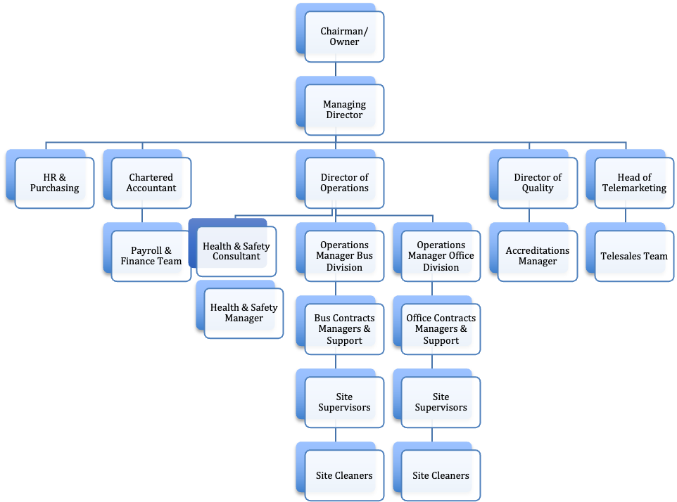

  - Health & Safety Representative
The Health & Safety Manager will undertake and be responsible for:
- Monitoring the implementation of the health & safety policy throughout the company and reviewing the appropriateness by regular safety audits/ inspections carried out in various workplaces.
- Investigating accidents and implementing corrective action
- Reviewing health & safety legislation and implementing any new requirements pertaining to the company’s undertaking
- Liaising with managers, employees, sub-contractors, and specialists as and when appropriate
- Collating and reporting any accidents reportable under the Reports of Injuries, Diseases and Dangerous Occurrences Regulations (R.I.D.D.O.R.) 2013

  - Employees
Section 7 of the Health & Safety at Work Act 1974 states the following:
It shall be the duty of every employee whilst at work: -
- To take responsible care for the health & safety of himself and of other persons who may be affected by his acts or omissions at work; and
- As regards any duty or requirements imposed on his employer or any other person by or under any of the relevant statutory provisions, to co-operate with him so far as is necessary to enable that duty or requirement to be performed or complied with.
In order for all employees to comply with their legal duties, they will undertake and be responsible for:
- Reading and having a working understanding Nationwide’s health & safety policy and carry out their work safety and in accordance with its requirements. (staff will be measured by a question and answer test as to this understanding).
- Ensuring that all protective equipment provided under a legal requirement is properly used in relation to any instruction/ training given and in accordance with this health & safety policy
- Reporting any defects to work equipment immediately to the Site Supervisor
- Reporting any accidents or near misses however minor to the Site Supervisor
- Using the correct tools and equipment for the job in hand and in accordance with training and instructions
- Co-operating with any investigation, which may be undertaken with the objective of preventing reoccurrence of incidents

- Health & Safety Arrangements
5.1 Health & Safety Management System
A full Health & Safety Management System is central to the way in which Nationwide manages its responsibility and commitment. This document can be found at every site in the Health & Safety Manual. Should you require further explanation please do discuss with your line manager. The following is an extract from the introduction of the Health & Safety Management System.
Nationwide delivers cleaning services to all areas of the Public Transport Industry and Offices. As a result, not all of the positions details may be operating within your contract. It depends on the Customer’s requirements, get to know the roles required by your customer, be flexible in your approach but never attempt to carry out duties beyond your authority or competency levels. Never attempt to carry out duties beyond your authority, competency levels and/ or training.
The future success of this and every contract operated by the company depends upon the performance of all of our employees. Enjoy your job, play your part in building a team that delivers satisfaction to all of our customer’s. If we all do that everything else will follow, prosperity, growth, and job security. Finally:
NEVER TAKE RISKS, ALWAYS FOLLOW HEALTH AND SAFETY GUIDELINES
The guidance is aimed at Nationwide directors, managers with health and safety responsibility, as well as health and safety professionals. Employees’ representatives should also find it helpful. It:
- Describes the principles and management practices which provide the basis of effectives health and safety management.
- Sets out the issues which need to be addressed; and
- Can be used for developing improvement programmes, self-audit, or self-assessment.
The principles are universal but how far action is needed will depend on the size of the organisation, the hazards presented by its activities, products or services, and the adequacy of its existing arrangements.
  - Personal Protective Equipment Policy
This policy statement reads as follows:
‘To ensure that suitable personal protective equipment is provided to employees who may be exposed to a risk to their health or safety while at work, except where and to the extent that such a risk has been adequately controlled by other means which are equally or more effective.’
The full policy can be found in the Human Resource Manual held on each site. Should you require any further clarification please discuss with your line manager.
  - Accident Reporting Policy and Procedure
The following is an extract taken from the Accident Reporting Policy and Procedure.
Background
Organisations are required by Health and Safety law to have a procedure in place for the recording and reporting of all incidents. The key is a robust incident reporting system operating within a just and fair culture, with effective feedback mechanisms to facilitate change and for Nationwide Cleaning & Support Services Ltd (Nationwide) to demonstrate continuous learning.
This policy sets out guidance for reporting all types of incidents (or adverse event), and ‘near miss’ event, both within the organisation and to external stakeholders. All staff will be made aware of this process and their responsibilities during their induction to Nationwide.
Scope and Purpose
It is the policy of Nationwide that all incidents and near miss events are accurately documented, properly investigated by and promptly reported to the Risk Management Department.
All Nationwide personnel whether permanent, temporary, agency staff, volunteers, students in training, or contractors, are expected to report risks that they become aware of, whether these are a result of actual incidents, near misses, hazards or perceived risks.
This policy describes and sets out the process and expected timescales for the incident reporting system in operation in Nationwide. It includes reporting methods, and responsibilities for making, receiving, analysing, prioritising and acting on such reports.
All accidents must be reported within 24hrs to indidents@nationwidefm.com.
  - COSHH
All product used by Nationwide are supported by Safety Data Sheets provided by the relevant company. It is Nationwide’s policy that products should be used without the relevant, up to date, safety data sheet being provided. Staff are trained in COSHH.
5.5 Training (including manual handling).
Nationwide Cleaning & Support Services Ltd recognises the importance of ensuring that all its employees are competent to enable them to carry out their work activities in a safe and correct manner. The company will endeavour to introduce a programme of training designed to achieve NVQ level 2 status for its cleaning operatives and the CIEH Basic Health and Safety Certificate. In-house training will be carried out by Nationwide supervisors or our suppliers’ representatives.
Particular attention will be paid to the provision of training for employees required to drive our customer’s vehicles ensuring competence through competence assessments and provision of training prior to authorisation to drive being given by our customers.
Employees receive a 17 Stage Health & Safety Briefing training programme as well as a series of Toolbox Talks which include the following as standard: manual handling, working above your reach, controlling risk of cross contamination, avoiding slips trips and falls, workplace safety, personal protective equipment. Details of the training ‘modules’ can be found in the Human Resource Manual held on each site.
Records of training will be maintained by the company for a minimum of 3 years.
  - Risk Assessments/ Method Statements/ Safe Systems of Work
Method statements are produced to ensure that employees undertake their duties in as safe a method as possible. Each method statement is supported with a matching risk assessment. Both sets of documents are routinely reviewed on a regular basis or, should the occasion arise, as an ad-hoc review should an incident occur. Safe Systems of Work are colour coded instructions of do’s and don’t that are placed on notice boards at each site. Copies can also be found in the Health & Safety Manual held on each site.
  - Communication/ Consultation
Regular meetings are held between Operational Managers, Supervisors and employees where toolbox talks are undertaken, updates to new technology/ products are introduced. This also acts as an opportunity for staff to raise any ideas that they may have.
5.8 Staff Welfare
Nationwide staff have access to toilet/ wash facilities as well as designated eating and resting at each site, all line managers will ensure staff are aware of the welfare facilities available to them and monitor the facilities to ensure they remain suitable.
5.9 Emergencies
It is Nationwide’s policy to take account of fire hazards in the workplace. All employees have a duty to conduct their operations in such a way as to minimize the risk of fire. This involves compliance with Nationwide’s no smoking policy, keeping combustible materials from sources of ignition and avoiding unnecessary accumulation of combustible materials.
Site Supervisors are responsible for keeping their operating areas safe from fire, ensuring that their staff are trained in proper fire prevention practices and emergency procedures.

Action to be taken upon discovering a fire
- Do not try and tackle the fire yourself (unless trained to do so)
- Activate the nearest fire alarm to raise the alarm
- Leave the building by the nearest fire exit and proceed to the muster point
- Do not re-enter the building for any purpose until all clear has been given
Action upon hearing the fire alarm
- Stop working and calmly leave the building by the nearest fire exit
- Go directly to the muster point and await instructions
- Do not leave the muster point until all clear is given
- Do not re-enter the building for any purpose until all clear has been given
5.10 Work Equipment
All work equipment (including electrical equipment) used at work, as part of Nationwide’s undertaking will comply with the Provision and Use of Work Equipment Regulations (P.U.W.E.R.).

Before new equipment is introduced into the working environment, an assessment will be made by the Operations Manager and/ or Health & Safety Manager in order to ascertain that the equipment is suitable for its intended use.
No employee will use work equipment for which they have not received specific training.
No employee will knowingly misuse work equipment or remove any guards that are in place to minimize a specified risk.
All work equipment will be maintained and inspected at suitable intervals either internally by a competent person or by specialist external companies. The frequency of work equipment maintenance or inspection will be based on manufacturer’s guidance and industry best practice. Any maintenance / inspections undertaken on company equipment will be formally recorded with a hard copy left on file.
If any faults or damage are found on any equipment, stop using the work equipment and report the fault to your Supervisor
5.11 First Aid
Nationwide Cleaning & Support Services Ltd will assess its needs for First Aid requirements and ensure adequate first aid cover is provided for our staff. First Aiders will be suitably trained, and names of employees trained in first aid will be posted at each work location
5.12 Manual Handling
Nationwide Cleaning & Support Services Ltd assesses Manual Handling within all of its Risk Assessments. Manual handling includes lifting, lowering, pushing, pulling, holding or carrying objects. Do not attempt to handle a greater weight than you are capable of managing. Current guidelines recommend a maximum 25kg for men anÍd 20kg for women. This is based on a load that can be lifted or carried close to the body with no arm extension.
When handling loads avoid sudden movements ,or twisting your body. Most injuries occur when this is ignored.
Before handling a load, assess whether it has to be done, whether assistance from others would help or whether it could be done using mechanical means i.e. a fork or pallet truck. You should also consider if the load can be broken down to allow for more manageable loads to be moved.
Before carrying out any manual handling, you must ensure that the route you are taking is free from obstructions and is likely to remain so.
Refer to TR05 for full procedure
5.13 Auditing and Review
Nationwide Cleaning & Support Services Ltd will carry out regular H&S Audits when appropriate across all sites. Auditors will be suitably trained and competent to do so. The results of these audits will be available and shared with the client.
- Legislation
Nationwide Cleaning & Support Services Ltd will identify and comply with all Health and Safety legislation and standards
Approving Body/ Committee | Risk Management & Safety Committee
Signed | Gary Nourse (Managing Director)
Signed: | 
Date Approved: | Jan 2024
Target Audience: | All Interested Parties

DOCUMENT HISTORY
Date of Issue | Version No. | Next Review Date | Date Approved | Director Responsible for Change | Nature of Change
Jul-11 | 1 | Feb-14 | Jul-11 | Director of Operations | First Issue
Feb 12 | 2 | Feb 14 | Feb 12 | Director of Operations | Policy update making reference to other supporting documentation
Nov 2013 | 3 | Nov 14 | 27/11/13 | Operations Director | Clarification ‘any reading on alcohol test is a failure’
October 2017 | 4 | October 2017 | 02/12/17 | Risk & Safety Manager | Change to RIDDOR Regulations (2005 to 2013)
October 2017 | 4 | Jan 2019 | 31.1.18 | Risk & Safety Manager | Date review
October 2018 | 4 | October 2019 | 07.11.18 | Risk & Safety Manager | Reviewed
November 2019 | 5 | Nov 2020 | 12.11.19 | Risk & Safety Manager | Reviewed
November2020 | 6 | Nov 2021 | 12/11/2020 | Risk& Safety Manager | Reviewed
November 2021 | 7 | Nov 2022 | 21/11/2021 | Risk& Safety Manager | Reviewed / Minor name changes
Jan 2022 | 8 | Jan 2023 | 10/01/2022 | Risk& Safety Manager | Reviewed and changes made in line with Safe Contractor recommendations.
Jan 2022 | 8 | Jan 2023 | 06/01/2022 | Risk& Safety Manager | Reviewed and changes made in line with Safe Contractor recommendations.
Jan 2023 | 9 | Jan 2024 | 31/01/2023 | Risk& Safety Manager | Reviewed – no changes
Jan 2024 | 10 | Jan 2025 | 10/01/2024 | H&S Consultant | Manual Handling added to Policy
Jan 2024 | 10 | Jan 2026 | 04/01/202 | H&S Consultant | Manual Handling added to Policy

Health and Safety at Work Act 1974, Management of Health and Safety Regulations 1992/ 99, Reporting of Injuries, Diseases and Dangerous Occurrence Regulations 2013 (RIDDOR)

