Manual Handling Policy

Introduction:

Over a third of all injuries at work are caused by manual handling. Most of the injuries are to hands, feet, legs and back. Some back injuries can result in permanent disability. Although the Manual Handling Operations Regulations do not specify what weight a person can lift, it is now recognised that one person should not lift any load exceeding 20kg (44lbs). However, the amount that an individual can lift comfortably depends on many factors, including their physical fitness, build etc.

Manual handling in construction is unavoidable, thus it is essential that it is carried out correctly to avoid both immediate and long-term injuries.

- The primary aim is to eliminate manual handling so far as is reasonably practicable (ie use mechanical handling).
- Where manual handling must be carried out then it must be assessed, and proper procedures must be used.
- Plan deliveries and storage to take into account load sizes, locations and distribution.
- Assess all loads: are they heavy, bulky, unstable, difficult to grasp, sharp etc? Size up the load and, if necessary, make a trial lift by rocking it from side to side and then lifting it a few inches.
- Can you handle the load yourself or do you need assistance?
- Wear suitable clothing and PPE such as gloves and safety boots to protect against cuts, crushed toes etc.
- Is there sufficient space, suitable lighting and a clear route to where you are taking the load?
- Do not carry a load that will obscure your vision.
- If necessary move loads in stages.
- Always use a good handling technique:

  - Stand reasonably close to the load, feet hip width apart with one foot slightly forward pointing in the direction you’re going.
  - Bend your knees whilst keeping your back straight.
  - Get a secure grip on the load.
  - Breathe in before commencing the lift.
  - Carry out the lift smoothly using the legs to take the strain, keeping the back straight, chin up, and arms close to the body.
  - Step off in the direction the advanced foot is pointing, keeping the load close to the body.
  - If necessary, stop for rests en-route.
  - Avoid any jerky or twisting movements.

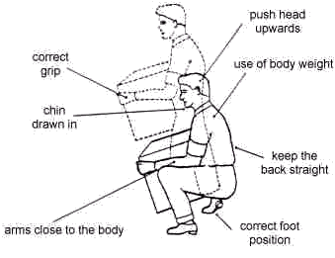

GET IT WRONG TODAY AND YOU COULD SUFFER THE CONSEQUENCES TOMORROW – AND POTENTIALLY FOR THE REST OF YOUR LIFE!

