# Health and Safety Policy Arrangements.

# Stress Management Policy

Version number: 01

Owner: Nationwide Cleaning and Support Services ,Airport House ,Purley way Croydon.CR0 0XZ.

Approved by: Oby Akabuogu (Health, Safety ,Risk & Training Manager).

Date:29/01/2024. Reviewed By Daniel Looney: 5/6/25

## Contents

Section Page

Contents 2

Regulatory/legal 3

01 Scope 3

02 Introduction 3

03 Objective 3

04 Definition of Stress 4

05 Approach 4

06 Responsibilities 4

07 Stress Risk Assessment 5

08 Monitoring 6

09 Training and awareness 6

10 Appendices/References 6   
  
Appendix 1 Stress Management Standards 7Appendix 2 Stress Management Checklist 8-11Appendix 3 Stress Risk Assessment 12  
Appendix 4

Stress Flow Chart 13  
  
11 Version control 14

12 Policy approval history 14

## Regulatory/legal

|  |  |
| --- | --- |
| Regulatory body | Regulation |
| Health and Safety Executive | **Health and Safety at Work Act 1974**  Puts a duty of care on employers to protect their employees from risk of stress at work. |
| **Management of Health and Safety at Work Regulations 1999** Requires employers to make a ‘suitable and sufficient assessment’ of the risks to health and safety of their employees at work. |

## 01 Scope

This Policy forms part of the Arrangements section to the Nationwide cleaning and support services Health and Safety Policy (version number 1, 29/01/2024). It applies to Nationwide activities taking place in all UK based business entities and it extends to any new acquisition within any of these entities, based in the UK that occur during the policy period.

## 02 Introduction

Nationwide cleaning and support services recognises the importance of maintaining a positive and supportive working environment to protect our most valuable asset, our employees. We accept that stressors in the workplace can have a detrimental and negative impact on both our organisation and individuals.

Nationwide is committed to protecting the health, safety and welfare of its employees and aims to deliver a consistent approach to the prevention and management of occupational stress throughout the organisation.

## 03 Objective

This policy supports a culture which proactively identifies stressors, takes early action to manage the situation and promotes wellbeing for all employees.

We will ensure:

* Conduct risk assessments to identify all workplace stressors, and eliminate or control the risks from stress – this will then be reviewed regularly.
* Provide training for all line managers and supervisors in adopting positive management practices.
* Provide confidential assistance for staff affected by stress, which may be caused by either work or external factors.
* Provide the resources necessary to enable managers to implement Nationwide’s stress management policy and procedures.

## 04 Definition of Stress

Health and Safety Executive (HSE) defines stress as ‘the adverse reaction people have to excessive pressure or other types of demand placed on them’.   
  
This highlights an important distinction between pressure, which can be positive if managed appropriately, and stress, which is likely to be detrimental to an individual’s physical or mental health if it is prolonged.

05 Approach

Our approach will reflect the recommendations set by the Health & Safety Executive (HSE), which is based on a set of ‘Management Standards’ primarily concentrating on six key areas:

|  |  |
| --- | --- |
| **Demands** | Includes workload, work patterns and the work environment. |
| **Control** | How much say a person has in the way they do their work. |
| **Support** | Includes the encouragement, sponsorship and resources provided by the organisation, line management and colleagues. |
| **Role** | Whether people understand their role within the organisation and whether the organisation ensures that they do not have conflicting roles. |
| **Change** | How organisational change (large or small) is managed and communicated in the organisation. |
| **Relationships** | Promoting positive working to avoid conflict and dealing with unacceptable behaviour. |

## 06 Responsibilities

**Managers will**:

* Undertake and implement recommendations of stress risk assessments.
* Maintain good communication between management and staff.
* Monitor workloads to ensure people are not overloaded.
* Monitor working hours and any overtime to ensure staff are not overworking and monitoring holiday to ensure staff are taking their full entitlement.
* Offer additional support as required for individuals who may be experiencing stress outside of work, such as bereavement etc.

**Human resources (HR) will:**

* Manage the absence policy, keeping sickness absence records and looking for ‘trigger points’ of repeated short absence or high staff turnover.
* Ensure that all new starters are signposted to electronic or paper information on Nationwide’s stress management arrangement and how to seek help from the Employee Assistance Programme.
* Encourage the use of Nationwide’s mentoring scheme for anyone who needs confidential mentoring support

**Employees will:**

* Raise any stress-related issues to their line manager or HR for both their work role and anything impacting on their mental wellbeing in their personal life outside of work.
* Take an active role in assessing the risks of stress in the workplace (i.e. completing staff satisfaction surveys).
* Appropriately make use of the resources available to them, such as Employee Assistance Programme.

**Mental Health first aiders will:**

* Aim to recognise the early signs and symptoms of common workplace mental health illnesses
* Act as a point of contact for an employee who is experiencing a mental health issue or emotional distress
* Possess the knowledge and confidence to guide colleagues to the appropriate professional support (such as employee assistance programmes)
* Promote greater awareness of mental health in the workplace

**The Health & Safety Team will:**

* Support managers in implementing stress risk assessments or well-being action plans.
* Monitor and review the effectiveness of measures to reduce stress.
* Provide support to the HR department by conducting specific stress risk assessments for   
  individuals who have been referred to HR due to stress.

## 07 Stress Risk Assessment

Stress is documented in the Nationwide’s office risk assessment and will be kept by Health & Safety and regularly reviewed to identify who is at risk from stress and how.

Line managers will carry out individual stress management checklists and seek assistance from HR and Health and Safety as required.

## 08 Monitoring

Anonymous data relating to staffs’ health and wellbeing is collected, monitored, and reported to the Health and Safety Committee monthly. This includes, annual leave, sickness absence data, and management referrals to Employee Assistance programme and number of completed stress risk assessments.

Local action plans will be requested from areas where data indicates that work related stress may be an issue in that part of the business.

## 09 Training and Awareness

A line manager training course will be developed by Nationwide, which will be rolled out to all line managers with resources that give guidance on how to spot the signs of stress and support employees.

## 10 Appendices/References

Appendix 1 Stress Management Standards Page 8Appendix 2 Stress Management Checklist Page 9-11Appendix 3 Stress Risk Assessment Page 12  
Appendix 4 Stress Flow Chart Page 13

Signed:

Gary Nourse

Director

1st April 2024

Appendix 1 Stress Management Standards

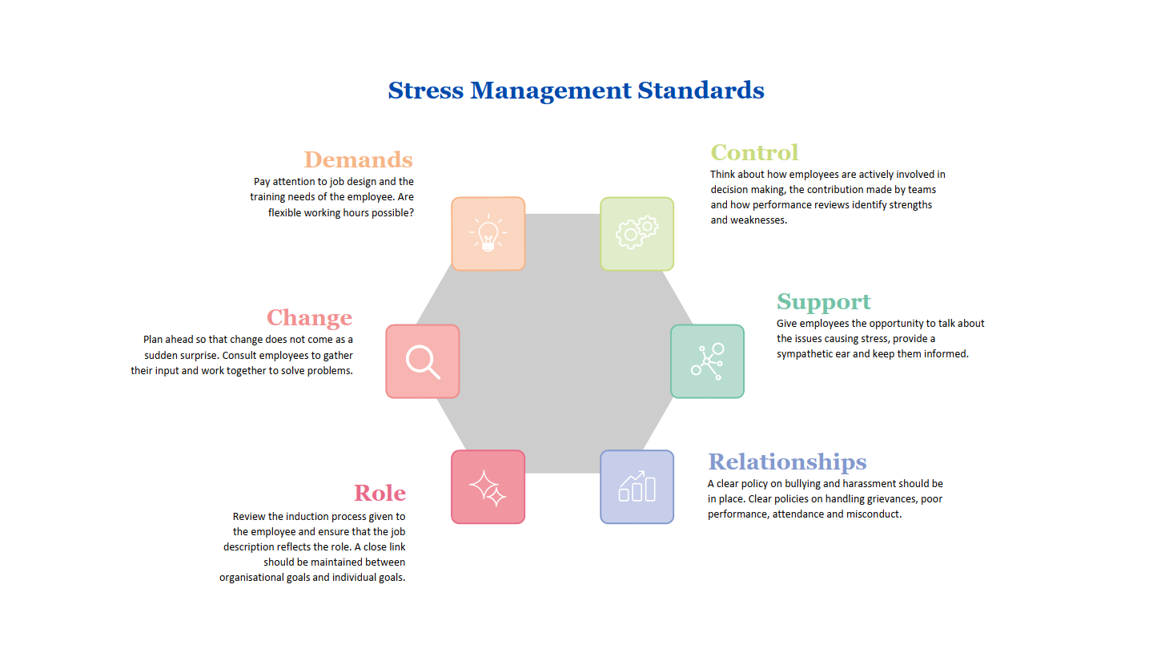

Appendix 2 Stress Management Checklist

**Stress Management Self-Assessment Checklist**

This Risk Assessment Checklist is designed as a guide for Line Managers and Staff when assessing the risks of stress. Particularly, following a return to work for a stress-related absence or on notification either directly from the employee, or via a third party. The checklist should be undertaken with the employee in private.

|  |  |
| --- | --- |
| **Employee Name** |  |
| **Job Title** |  |
| **Site** |  |
| **Completed By** |  |
| **Date** |  |

|  |  |  |
| --- | --- | --- |
| Privacy Declaration | | |
| Please ask the employee for their permission, under GDPR, to retain personal data and share it with the line manager, Health and Safety and HR. Has permission been granted? | YES | NO |
|  |  |

Note. If the employee does not wish to share this document with their line manager, confirm whether the employee is happy to discuss with their HR. If the employee prefers to discuss with neither, they may approach the Health and Safety team who will liaise direct with the employee and signpost to external agencies where appropriate.

|  |  |
| --- | --- |
| **Privacy Declaration** | |
|  |
|

|  |  |
| --- | --- |
| **1** | **Demands** |
| 1.1 | Do you feel you have just the right amount of work to do? Could you say what work you have too much/too little of? |
| 1.2 | Do you take the breaks you are entitled to at work? |
| 1.3 | What training, if any, would help you to do your job? |
| 1.4 | Are there any problems with your work environment? If yes, please describe: |

|  |  |
| --- | --- |
| **2** | **Control** |
| 2.1 | How could you have more say about how your job is done? |
| 2.2 | How could you be more included in decision-making in the team? |
| 2.3 | How could you be supported to use your skills to greater effect at work? |

|  |  |
| --- | --- |
| **3** | **Support** |
| 3.1 | How could your line manager better support you to do your job? |
| 3.2 | How could your colleagues better support you to do your job? |
| 3.3 | Are there any parts of your job that you find especially difficult? |
| 3.4 | Do you feel you have a healthy work-life balance? If not, how could it be better? |

|  |  |
| --- | --- |
| **4** | **Relationships** |
| 4.1 | How could communication in the team be improved? |
| 4.2 | Does the employee feel they are experiencing bullying or harassment at work? |

|  |  |
| --- | --- |
| **5** | **Role** |
| 5.1 | Are you clear about your roles and responsibilities at work? If not, please explain: |
| 5.2 | Do you feel that there is any ambiguity or confusion (role conflict) in your job? If yes, please describe: |

|  |  |
| --- | --- |
| **6** | **Change** |
| 6.1 | How could your line manager better support you during change at work? |
| 6.2 | How could the organisation better support you during change at work? |

**Stress Action Plan***(Line Manager / HR to complete)*

|  |  |
| --- | --- |
| **Employee Name** |  |
| **Line Manager** |  |
| **Review Date** |  |

|  |  |  |  |  |
| --- | --- | --- | --- | --- |
| **Type of Stressor** | **Existing workplace measures** | **Further action to be taken** | **Action Owner** | **Target Date** |
| **Demands** |  |  |  |  |
| **Control** |  |  |  |  |
| **Support** |  |  |  |  |
| **Relationships** |  |  |  |  |
| **Role** |  |  |  |  |
| **Change** |  |  |  |  |

Appendix 3 Stress Risk Assessment

***Nationwide’s General Office Risk Assessment V 1***

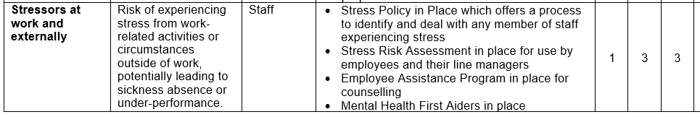

Appendix 4 Stress Flow Chart  
